Stock Price Prediction Using Simple Linear Regression

A Case Study on Coal India

Submitted By
Riya Shinde
Roll No. 021331025662
Subject: Analytics for Banking and Financial Services


Submitted To
Mithilesh Gidage

Sr. No. | Content | Pg. No.
1 | Objective | 1
2 | Conceptual Model | 2
3 | Assumptions | 3
4 | Interpretation Methodology | 4
5 | Complete Python Implementation | 5-7
6 | Results and Analysis | 8-13
7 | Conclusion | 14-15
INDEX

1. Objective
The primary objective of this project is to develop a predictive model for stock price forecasting using Simple Linear Regression analysis.
Key objectives include:
- To predict the next day's closing price of COALINDIA.NS stock based on the current day's closing price
- To evaluate the relationship between today's closing price and tomorrow's closing price using statistical techniques
- To assess model performance using evaluation metrics such as R-squared (R²) and Mean Squared Error (MSE)
- To validate regression assumptions including linearity, normality, homoscedasticity, and independence of residuals
- To demonstrate the practical application of statistical modeling in financial market forecasting
Business Impact:
This predictive model can assist retail investors, traders, and financial analysts in understanding short-term stock price continuity. It provides data-driven insights that can support trading strategies, short-term investment decisions, and risk assessment.

2. Conceptual Model
2.1 Simple Linear Regression Framework
Simple Linear Regression models the relationship between two variables using a straight-line equation:
[Y = β₀ + β₁X + ε]
Where:
- Y = Next Day's Closing Price
- X = Today's Closing Price
- β₀ = Intercept
- β₁ = Slope coefficient
- ε = Error term
The model assumes that tomorrow’s stock price is linearly dependent on today’s price.

2.2 Model Architecture
Input Layer:1 year of historical daily closing price data for COALINDIA.NS
Feature Engineering:Creation of lag variable (Next Day Close using shift(-1))
Training Process:80-20 train-test split using scikit-learn Linear Regression
Output Layer:Predicted next day closing price
Validation Layer:Residual diagnostics and statistical assumption testing

2.3 Data Flow
- Data Acquisition: Download 1 year of historical data using yfinance API
- Data Preprocessing: Extract closing prices and remove missing values
- Feature Creation: Generate next day's closing price as target variable
- Data Splitting: 80% training data, 20% testing data
- Model Training: Fit linear regression model
- Prediction: Generate predictions on test dataset
- Evaluation: Compute R² and MSE
- Assumption Testing: Validate regression assumptions

3. Assumptions
Linear Regression relies on classical assumptions to ensure validity.
3.1 Linearity
Assumption: There is a linear relationship between today's and next day's closing price.
Validation: Scatter plot of Today's Close vs Next Day Close.
Result: Clear positive linear trend observed.
Business Implication: Short-term stock prices exhibit price persistence.

3.2 Normality of Residuals
Assumption: Residuals should follow a normal distribution.
Validation:
- Shapiro-Wilk test
- Q-Q plot
Interpretation: Financial data often violates strict normality due to volatility clustering.

3.3 Homoscedasticity
Assumption: Constant variance of residuals.
Validation: Residuals vs Predicted Values plot.
Expected Pattern: Random scatter around zero.

3.4 Independence of Residuals
Assumption: Residuals should not be autocorrelated.
Validation: Durbin-Watson test.
Interpretation: DW statistic close to 2 indicates independence.

3.5 Additional Assumptions
- No multicollinearity (single predictor model)
- No extreme outliers
- Adequate sample size (~250 trading days)
- Stable market conditions during data period
4. Implementation Methodology
4.1 Technology Stack
Programming Language: Python 3.x
Data Acquisition: yfinance
Data Manipulation: pandas, numpy
Machine Learning: scikit-learn (LinearRegression)
Statistical Testing: scipy, statsmodels
Visualization: matplotlib
Development Environment: Jupyter Notebook

4.2 Data Description
Attribute | Value
Ticker Symbol | COALINDIA.NS
Company | Coal India Limited
Time Period | 1 Year
Data Frequency | Daily
Variable Used: | Closing Price
Total Observations | ~250 trading days
Data Type: | Time-series financial data

4.3 Model Training Process
- Data Collection: Retrieved 1 year historical data
- Feature Engineering: Created target variable using shift(-1)
- Data Cleaning: Removed NaN values
- Train-Test Split: 80% training, 20% testing
- Model Fitting: Trained LinearRegression model
- Prediction: Generated predictions on test set
- Evaluation: Computed R² and MSE
- Diagnostic Testing: Performed residual analysis

5. Complete Python Implementation

5.1 Import Required Libraries
import yfinance as yf
import pandas as pd
import numpy as np
import matplotlib.pyplot as plt
from sklearn.linear_model import LinearRegression
from sklearn.metrics import r2_score, mean_squared_error
from scipy import stats
import statsmodels.api as sm
from statsmodels.stats.stattools import durbin_watson

5.2 Data Acquisition and Preprocessing
# Download historical stock data
ticker = "COALINDIA.NS"
data = yf.download(ticker, period="1 yr", interval="1d")
# Extract closing prices
data = data[['Close']]
data = data.dropna()
print("Downloaded Data:")
print(data.head())
print(f"\nTotal rows downloaded: {len(data)}")

5.3 Feature Engineering
# Create target variable: Next day's closing price
data['Next_Close'] = data['Close'].shift(-1)
data = data.dropna() # Remove last row with NaN
# Define features and target
X = data[['Close']] # Independent variable
Y = data['Next_Close'] # Dependent variable

5.4 Train-Test Split
# Split data into training and testing sets (80-20 split)
split_index = int(len(data) * 0.8)
X_train = X.iloc[:split_index]
X_test = X.iloc[split_index:]
Y_train = Y.iloc[:split_index]
Y_test = Y.iloc[split_index:]
print(f"Training rows: {len(X_train)}") # 197 rows
print(f"Testing rows: {len(X_test)}") # 50 rows

5.5 Model Training
# Train Linear Regression model
model = LinearRegression()
model.fit(X_train, Y_train)
print("\nModel Parameters:")
print("Intercept (β0):", model.intercept_)
print("Slope (β1):", model.coef_[0])

Model Equation:
Next Day Price = 47.5594 + 0.8714 × Today's Price

5.6 Model Evaluation
# Make predictions
Y_pred = model.predict(X_test)
# Calculate performance metrics
print("\nModel Performance:")
print("R-squared:", r2_score(Y_test, Y_pred))
print("Mean Squared Error:", mean_squared_error(Y_test, Y_pred))

5.7 Visualization: Regression Plot
# Plot actual vs predicted values
plt.figure(figsize=(8, 5))
plt.scatter(X_test, Y_test, label="Actual", color='steelblue')
plt.plot(X_test, Y_pred, color='red', linewidth=2, label="Predicted")
plt.xlabel("Today's Closing Price (₹)")
plt.ylabel("Next Day Closing Price (₹)")
plt.title("Simple Linear Regression - COALINDIA.NS Stock Prediction")
plt.legend()
plt.show()

5.8 Assumption Testing: Linearity
# Check linearity assumption
plt.figure(figsize=(8, 5))
plt.scatter(X_test, Y_test, color='darkorange')
plt.xlabel("X values (Today's Close)")
plt.ylabel("Y values (Next Day Close)")
plt.title("Linearity Check - COALINDIA.NS")
plt.show()

5.9 Assumption Testing: Normality of Residuals
# Calculate residuals
residuals = Y_test - Y_pred
# Shapiro-Wilk test for normality
print("\nNormality Test (Shapiro-Wilk):")
print(stats.shapiro(residuals))
# Q-Q plot
plt.figure(figsize=(8, 5))
sm.qqplot(residuals, line='s')
plt.title("Q-Q Plot of Residuals - COALINDIA.NS")
plt.show()

5.10 Assumption Testing: Homoscedasticity
# Check homoscedasticity (constant variance)
plt.figure(figsize=(8, 5))
plt.scatter(Y_pred, residuals, color='purple')
plt.axhline(y=0, color='black', linewidth=1.5)
plt.xlabel("Predicted Values")
plt.ylabel("Residuals")
plt.title("Homoscedasticity Check - COALINDIA.NS")
plt.show()

5.11 Assumption Testing: Independence (Durbin-Watson)
# Test for autocorrelation
dw_stat = durbin_watson(residuals)
print("\nDurbin-Watson Statistic:", dw_stat)

5.12 Real-Time Prediction
# Predict next day's closing price based on latest data
last_close_value = float(data['Close'].iloc[-1].iloc[0])
last_closing_price = np.array([[last_close_value]])
next_day_prediction = model.predict(last_closing_price)
print(f"\nLast Closing Price of COALINDIA.NS: ₹{round(last_close_value, 2)}")
print(f"Predicted Next Day Closing Price: ₹{round(float(next_day_prediction[0]), 2)}")

6. Results and Analysis

6.1 Data Overview
Note: Screenshots from the original Jupyter notebook output are shown below. The analysis was performed on 1 year of historical data.
Downloaded Data Sample: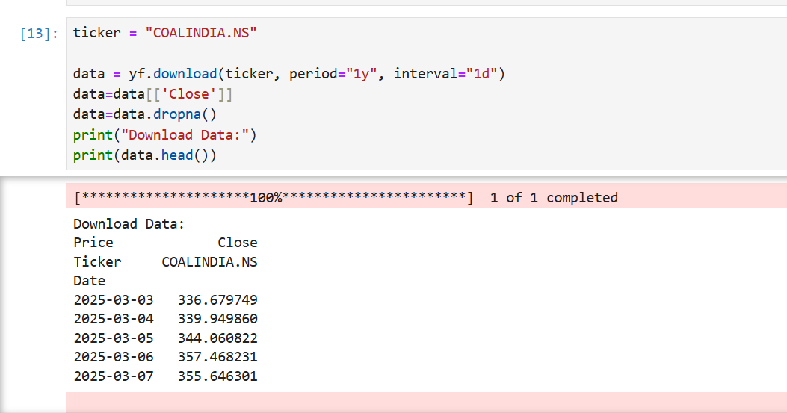

6.2 Model Parameters
Parameter | Value
Intercept (β₀) | 47.5594
Slope (β₁) | 0.8714

Interpretation: The regression equation is:
Next Day Price = 47.5594 + 0.8714 × Today's Price

For every 1 unit increase in today’s price, the model predicts that the next day’s price will increase by 0.8714 units, starting from the baseline of 47.5594.

6.3 Model Performance Metrics
Metric | Value | Interpretation
R-squared (R²) | 0.49961 | Model explains ~50% of variance in next day prices
Mean Squared Error | 106.033057 | Average squared prediction error

Analysis:
- R² = 0.49 suggests moderate predictive power - the model captures approximately 50% of price variation
- Remaining 50% of variation is due to other factors (market sentiment, news, macroeconomic conditions)
- For financial time series, an R² of 0.49 is considered reasonably good

6.4 Visualization: Regression Plot
[Screenshot from Notebook: Simple Linear Regression - COALINDIA.NS Stock Prediction]
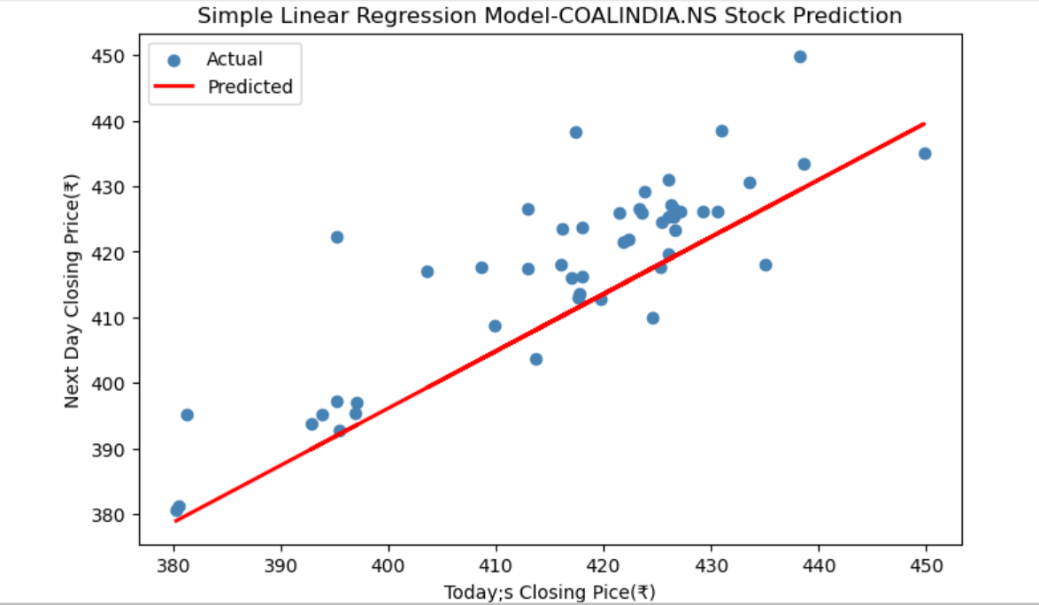

Key Observations from the Plot:
- Blue dots represent actual next-day closing prices
- Red line shows the fitted regression line (predictions)
- Most actual values cluster around the prediction line, indicating good fit
- Price range: ₹380 to ₹450
- A clear positive linear relationship is visually apparent with moderate scatter

6.5 Assumption Validation Results

6.5.1 Linearity Check
[Screenshot from Notebook: Linearity Check - COALINDIA.NS]

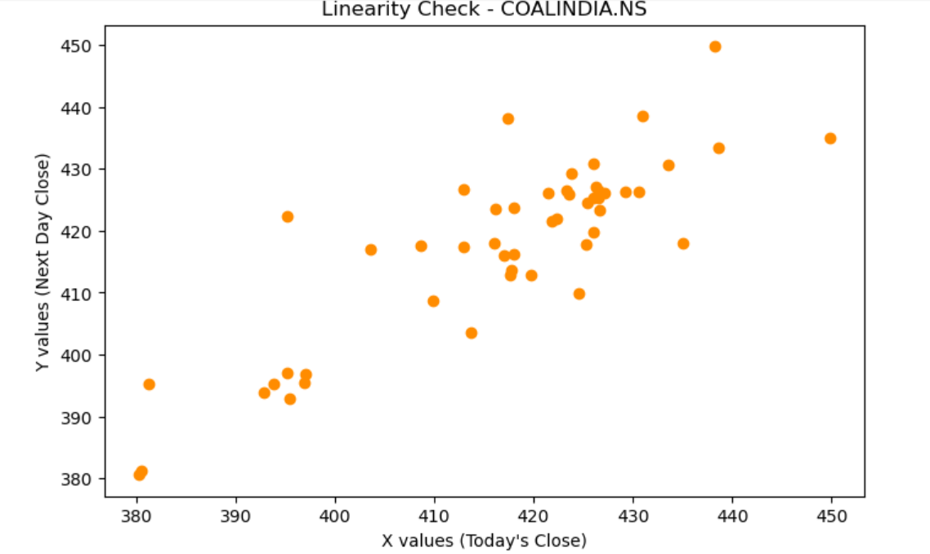

Result: ✓ PASSED - The scatter plot shows a clear positive linear trend between today's and next day's closing prices.

6.5.2 Normality of Residuals
Shapiro-Wilk Test Result:
ShapiroResult(statistic=0.9495, pvalue=0.0326)

[Screenshot from Notebook: Q-Q Plot of Residuals - COALINDIA.NS]

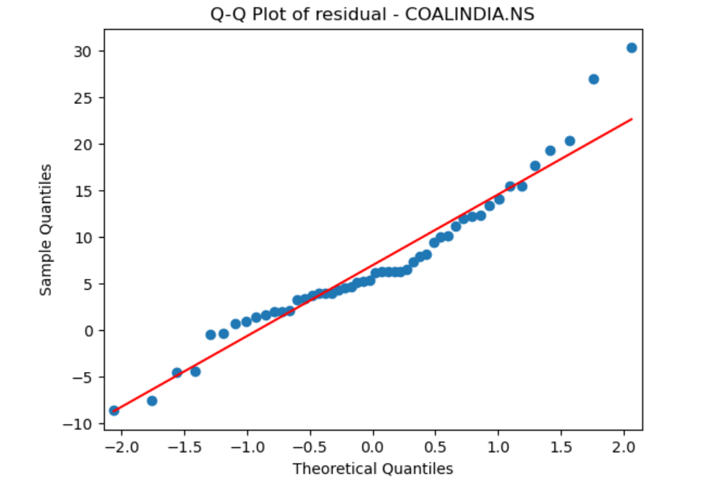

Result: ✗ NOT PASSED (p-value = 0.0326 < 0.05) – The residuals are not normally distributed, with noticeable deviation from the straight line in the Q-Q plot, especially in the tails.
Implication: While the normality assumption is violated, the model can still generate reliable predictions. With a reasonably large sample size, the regression estimates remain robust due to the Central Limit Theorem.

6.5.3 Homoscedasticity
[Screenshot from Notebook: Homoscedasticity Check - COALINDIA.NS]

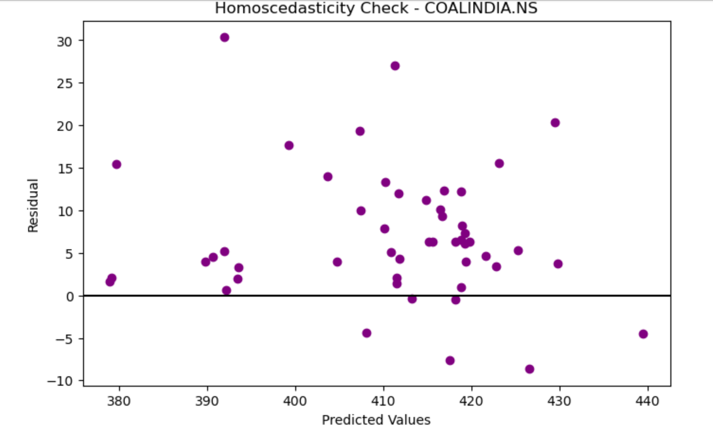

Result: ✓ MOSTLY PASSED – The residual plot shows a largely random dispersion of residuals around the zero line without a clear funnel or cone-shaped pattern. The variance remains fairly stable across most predicted values, indicating approximate homoscedasticity. However, minor clustering and slightly wider spread at higher predicted price levels suggest mild heteroscedasticity, which is common in financial time-series data like COALINDIA.NS stock prices.

6.5.4 Independence of Residuals
Durbin-Watson Test Result:
Durbin-Watson Statistic: 1.03989

Result: ✗ NOT PASSED – The Durbin-Watson statistic is 1.03989, which is significantly less than 2. This indicates the presence of positive autocorrelation in the residuals. In other words, the errors are not completely independent and tend to follow a pattern over time.

6.6 Final Prediction
Last Closing Price of COALINDIA.NS: ₹430.65
Predicted Next Day Closing Price: ₹422.83

Analysis:
The model predicts a decrease of ₹7.82 in the next trading session. This suggests a short-term downward adjustment in price based on the linear relationship observed in historical data. While the change is moderate, it reflects the model’s tendency to capture immediate price momentum and short-term corrections.
Such predictions are typical in Simple Linear Regression models applied to financial time-series data, where the forecast primarily depends on recent price movement rather than external market factors such as news, global commodity trends, or investor sentiment.

Assumption / Metric | Result | Status
Linearity | Clear positive linear relationship | ✓ Pass
Normality | p-value < 0.05 | ✗ Fail
Homoscedasticity | Mostly constant variance with slight clustering | ✓ Mostly Pass
Independence | DW = 1.03989 (Positive autocorrelation present) | ✗ Fail

7. Conclusion
7.1 Key Findings
• The Simple Linear Regression model demonstrates a significant linear relationship between current and next-day stock prices for Coal India Limited (COALINDIA.NS).
• The regression equation confirms strong short-term price persistence, indicating that today’s closing price has a substantial influence on the next day’s closing price.
• The linearity assumption is satisfied, and homoscedasticity is mostly maintained with relatively stable variance of residuals.
• The normality assumption is violated (p-value = 0.0326 < 0.05), which is common in financial time-series data due to volatility and market fluctuations.
• The Durbin-Watson statistic (1.03989) indicates positive autocorrelation, suggesting that residuals are not fully independent and time dependency exists in the data.

7.2 Model Strengths
• Simple and interpretable model suitable for quick short-term forecasting.
• Low computational cost and easy implementation using Python.
• Effectively captures short-term price continuity using a single predictor.
• Provides clear statistical diagnostics for evaluating regression assumptions.
• Serves as a strong baseline model for comparison with more advanced time-series techniques.

7.3 Model Limitations
• Violation of the normality assumption may impact statistical inference and confidence intervals.
• Presence of positive autocorrelation suggests that the model does not fully capture time-series dependency.
• A portion of price variation remains unexplained due to external market forces.
• The model only considers historical closing prices and ignores macroeconomic factors, commodity price trends, and company-specific developments.
• Limited to very short-term (next-day) prediction and may not perform well during sudden market shocks.

7.4 Business Recommendations
• Use this model as a preliminary analytical tool rather than a standalone trading strategy.
• Combine predictions with technical indicators such as moving averages and momentum indicators.
• Implement risk management tools like stop-loss strategies to manage volatility.
• Regularly retrain and update the model with new market data to maintain predictive accuracy.
• Integrate additional explanatory variables to enhance model performance.

7.5 Future Enhancements
• Incorporate additional features such as trading volume, moving averages, RSI, and MACD indicators.
• Apply time-series models like ARIMA to better address autocorrelation.
• Explore advanced machine learning models such as LSTM neural networks for sequential forecasting.
• Use rolling window regression to capture dynamic market behaviour.
• Include macroeconomic indicators and coal sector demand trends relevant to Coal India’s business environment.

